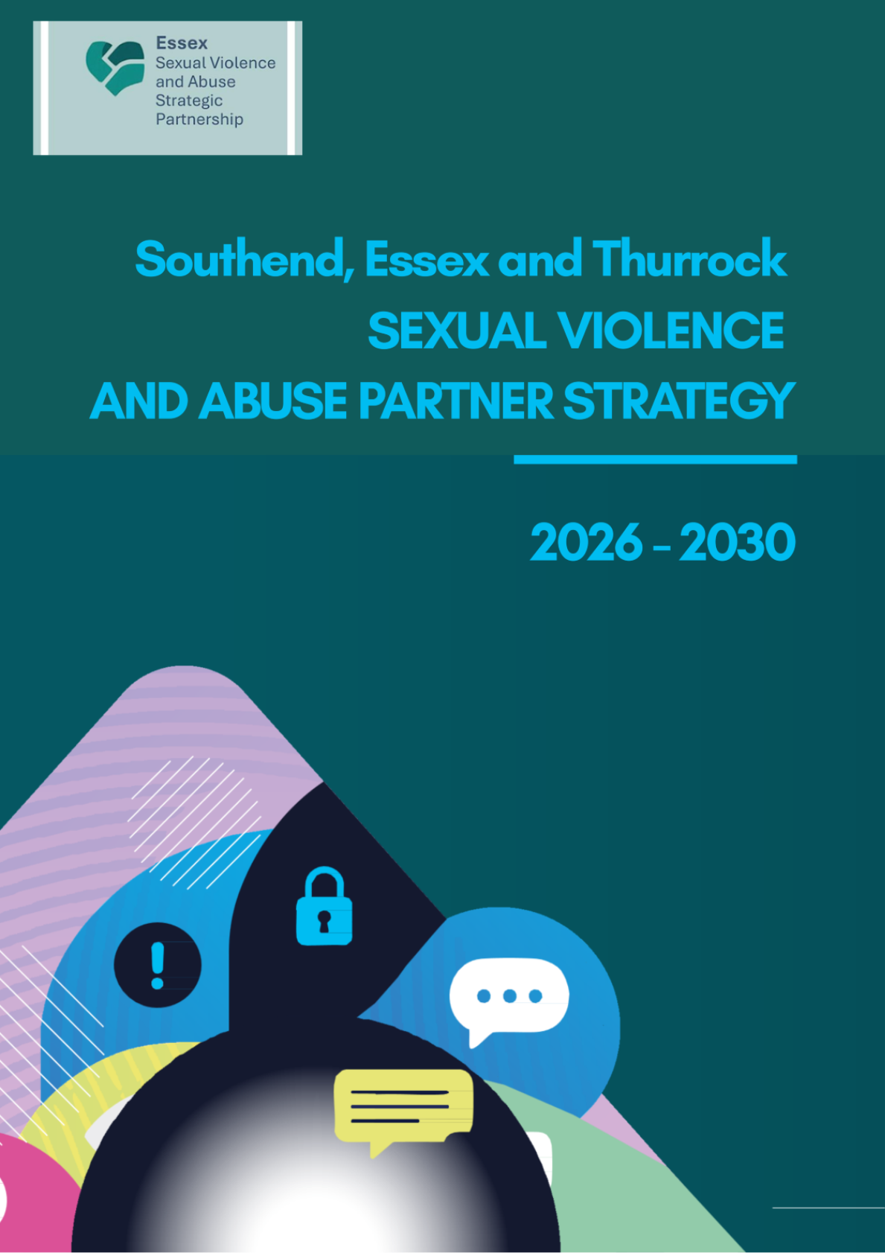

Version 3.0 SIGNED SVASPB May 2026

Table of Contents
Foreword 3
Executive Summary 5
1.0 Introduction 8
1.1 Definition and Terminology 8
1.2 Links to related guidance, strategies and Partnerships 9
1.3 Consequences of Violence 12
2.0 Background 13
2.1 National Context 13
2.2 Local Context 15
2.3 Lived Experience 19
2.4 Barriers / Thematics 19
3.0 Strategic Vision and Aims 20
3.1 Strategic Vision 20
3.2 Mission Statement 20
3.3 Thematic Areas 20
4.0 Community Equality Impact Assessment 22
5.0 Monitoring and Evaluation 23
5.1 Governance 23
5.2 Delivery and Outcomes Framework 23
6.0 Risks and Challenges 26
6.1 National 26
6.2 Local 26
7.0 Appendices 27
7.1 Community Equality Impact Assessment 27
7.2 Definitions 27
7.3 Legal Framework and Related Strategies 29
7.4 Evidencing the Cost 31
7.5 Glossary 32
8.0 Services and Support available for Victims and Survivors 33

Foreword:
shared ambition—"to create a safer, more secure Greater Essex for everyone.”

It is my privilege to co-chair the Sexual Violence and Abuse Strategic Partnership, through which organisations across Greater Essex come together to ensure an effective partnership response to these heinous crimes. Delivery of this strategy is vital to achieving this ambition.
The trauma caused by sexual violence and abuse, and the personal cost – not just to victims and survivors but also to their families and loved ones – should not be under-estimated. The cost to local services and the economy is also significant. The estimated lifetime cost of sexual violence and abuse across Southend, Essex and Thurrock is £13.8 billion, reflecting the impact on services including health and social care, criminal justice agencies, and specialist services, as well as lost productivity.
Across the partnership, we have made huge progress and improvements over recent years, and continue to do so, but we are still in a position where many of these crimes are never reported, where too few offenders are brought to justice, where those victims and survivors who do get justice wait too long for it, and where our referrals pathways into specialist support services remain chronically under-funded. The advent of the internet, in particular, means that our children and young people are growing up in a very different world, and interact in very different ways, than the world that I and many current professionals grew up and trained in, which means that we need a very different response now.
Through this strategy, we aim to increase the confidence of victims, witnesses and professionals, and be clear and consistent in our expectation that Greater Essex is somewhere everyone can and should feel safe in their homes, workplaces and communities. To achieve this, we need not just a whole system approach but a whole of society approach which makes sexual violence and abuse entirely unacceptable at all levels, where we prevent these crimes wherever we can, and respond swiftly, compassionately and in a way that puts the victim at the centre where such crimes are committed. This will mean engaging communities in open, honest and sometime uncomfortable conversations that challenge stigma, promote awareness and drive meaningful change within agencies and communities. It will also mean being more attentive to victims’ voices, so we can better understand and respond to their experiences.
I have worked in multiple counties, and we are fortunate across Greater Essex to have the most thriving voluntary and community sector, certainly that I have ever worked in. We rely hugely on this sector to provide support to victims and survivors, their families and loved ones, so it concerns me that, over the life of this strategy, all the major commissioners of these services (health, local government and policing) will be undergoing major reform. As we progress through devolution and public sector reorganisation, we must not lose sight of the fact that the fundamental business of local government and the wider public sector is place shaping, and that delivery of this strategy will play a critical role in shaping the place we want Greater Essex to be in future. It is therefore incumbent on all of us in leadership positions across these sectors to ensure that commissioned services are sustained through this period of change and come out the other side stronger and more sustainable than ever before.
Let’s get to work.
Pippa Brent-Isherwood, BA(Hons), Pg Dip, MCMI
Chief Executive and Monitoring Officer to the Police, Fire and Crime Commissioner

As Co-Chair of the Essex Sexual Violence and Abuse Strategic Partnership, I am acutely aware of the profound and far-reaching impact that sexual violence and abuse have on individuals, families, and communities. These experiences are not only devastating in their immediate harm but often carry lifelong consequences for physical health, mental wellbeing, and social outcomes.
In Essex, health services can often be the first point of contact for victims and survivors. Whether presenting in primary care, emergency departments, mental health services, or specialist provision, the health system plays a critical and unique role in identification, early intervention, treatment, and long-term recovery. This places a significant responsibility on us—not only to respond effectively but to do so with compassion, consistency, and a trauma-informed approach.
The scale and complexity of need require a coordinated, system-wide response. Sexual violence and abuse are intrinsically linked to a range of health inequalities, including poorer mental health outcomes, chronic physical conditions, substance misuse, and increased demand on urgent and unscheduled care. Addressing these issues is not solely a matter of safeguarding—it is fundamental to improving population health and reducing health disparities across Essex.
This strategy reflects our collective commitment across health, local authorities, policing, and the voluntary sector to strengthen prevention, improve access to high-quality care, and ensure that every individual affected receives the support they need at the right time. It also recognises the importance of listening to survivors, whose experiences must continue to shape how services are designed and delivered.
For health services in Essex, this strategy is both a call to action and a framework for change. It challenges us to build workforce capability, enhance data and intelligence, improve pathways, and ensure that services are accessible, equitable, and responsive to diverse communities.
Dr Giles Thorpe RN, BSc (Hons), MSc, DProf, MIHM (He/Him/His)
Executive Chief Nurse, NHS Essex Integrated Care Board

I fully support the Southend, Essex and Thurrock Sexual Violence and Abuse Strategy. Sexual violence and abuse cause lasting harm, and our communities deserve a justice system that responds decisively, supports victims with compassion, and holds perpetrators to account.

Central to this strategy is a commitment to improving the quality, consistency and pace of our criminal justice response. Through Operation Soteria, Essex Police is strengthening suspect focused, victim-centred and context-led investigations, improving file quality, and working closely with the Crown Prosecution Service to reduce delays and reduce the levels of victim attrition seen both locally and nationally.

Justice is not defined solely by court outcomes. It includes victims feeling heard, safe and supported throughout their journey. That requires strong partnerships, clear communication, and a trauma-informed approach at every stage. We will continue to use all available tools, including specialist advocates, risk management frameworks and multi-agency safeguarding arrangements to reduce harm and prevent reoffending.

This strategy reflects a shared determination across Greater Essex to deliver a more effective, more accountable system of protection and justice. Essex Police is proud to play its part in that collective effort.

Scott Cannon, Detective Chief Superintendent, Head of Crime & Public Protection Command, Essex Police

Executive Summary:
The Southend, Essex and Thurrock (SET) Sexual Violence and Abuse Strategy (2026–2030) sets out a comprehensive, multi-agency plan to prevent, respond to, and mitigate the impact of sexual violence and abuse (SVA) across Southend, Essex and Thurrock. Recognising SVA as both a public health issue and a criminal justice priority, the strategy adopts a whole-system approach that addresses root causes, mitigates harm, and promotes long-term societal change.
Why This Strategy Matters
Sexual violence and abuse have profound and lasting consequences on victims, families, and communities—impacting mental and physical health, relationships, and economic stability. The estimated lifetime cost of SVA across services in Greater Essex exceeds £13 billion, underscoring the urgent need for coordinated prevention and intervention.
Our Vision
Our vision is for partners across Southend, Essex and Thurrock to work together to prevent sexual violence and abuse, understand the prevalence and trends, reduce harm, and ensure that victims, witnesses and their families feel safe, empowered and confident to report and access specialist services should they choose to. We will acknowledge and respond to situations that may increase vulnerability, ensuring that support is accessible and sensitive to individual needs. Where SVA occurs, we will mitigate its impact through coordinated, trauma informed specialist services and by working collectively to hold perpetrators to account.

This will be delivered under the 5 themes of:
- Awareness and Attitudes​
- Support, Service Provision and Recovery
- Prevention and Early Intervention​
- Justice and Accountability​
- System Working

Public Health Approach
This strategy frames sexual violence and abuse as a preventable harm, focusing on:
- Primary prevention: Education, awareness raising, and cultural change to stop violence and abuse before they occur.
- Secondary prevention: Early identification of risk factors and timely intervention for victims and potential perpetrators.
- Tertiary prevention: Reducing long-term harm through accessible, trauma-informed specialist recovery services and offender management.
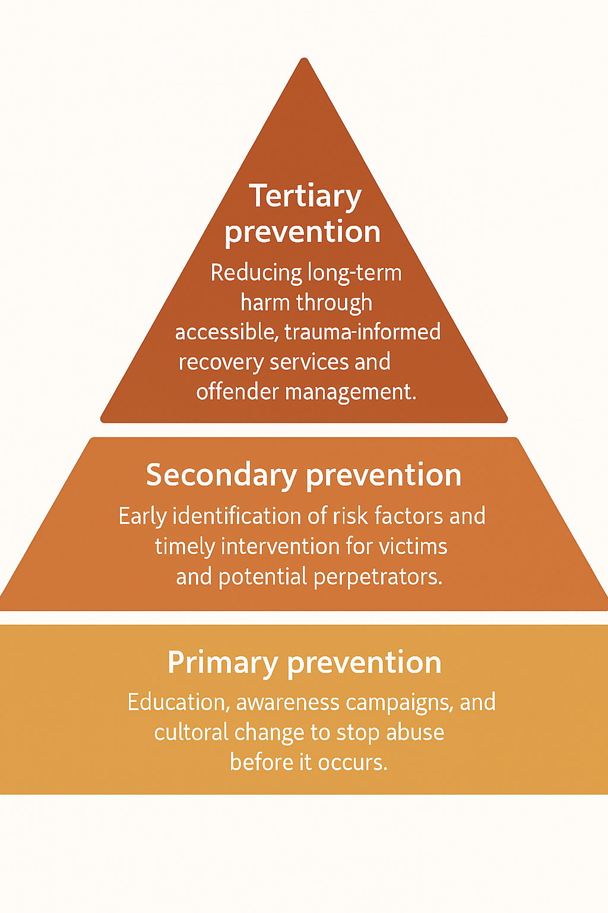
Strategic Priorities
- Align with legal definitions and consent principles – Grounded in the Sexual Offences Act 2003, Sexual Offences 1956 Act where relevant and Equality Act 2010, ensuring clarity and compliance.
- Provide workforce training – Equip professionals with legal knowledge and trauma-informed skills to identify, respond to, and support victims effectively using informed referrals.
- Embed trauma-informed, victim-centered practices – All commissioned services will adopt approaches that recognise the impact of trauma and prioritise victim safety and empowerment.
- Implement prevention and early intervention programmes – Deliver age-appropriate Relationships and Sex Education (RSE), community engagement, and targeted interventions for high-risk groups.
- Integrate offender management tools – Use Sexual Harm Prevention Orders (SHPOs), Sexual Risk Orders (SROs), and Multi-Agency Public Protection Arrangements (MAPPA) to manage risk and prevent reoffending.
- Promote multi-agency coordination and intelligence sharing – Strengthen collaboration between police, health, education, social care, specialist services and voluntary sector organisations under the Serious Violence Duty and Victims and Prisoners Act 2024 (the latter introduces the statutory duty to collaborate)
- Monitor and evaluate effectiveness – Establish a robust outcomes framework with clear metrics on reporting rates, repeat victimisation, victim satisfaction, and criminal justice outcomes.
Through this strategy, partners will work collectively to reduce harm, improve outcomes, and build safer communities. By embedding a public health approach, Greater Essex aims to shift from reactive responses to proactive prevention—creating lasting change for future generations.
Coordinated Community Response Model
This diagram illustrates the coordinated community response to sexual violence and abuse, showing prevention layers, multi-agency partners, and victim pathways.
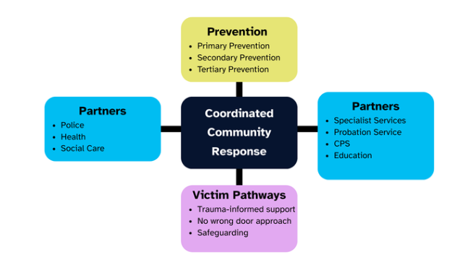

The key drivers for why Greater Essex has developed a Sexual Violence and Abuse Strategy are to:

- Protect those already known to public agencies or eligible for support, including
– those who may experience vulnerability due to specific situations or circumstances, disabilities, mental ill-health, homelessness, immigration status and members of the LGBTQIA+ community.
- Create a safe and inclusive environment – Fostering cultures of respect, dignity and inclusivity.
- Create a culture of accountability - Ensuring that clear procedures for reporting suspected abuse and conducting thorough investigations are in place.
- Support collaboration – A multi-faceted approach involving collaboration between agencies including healthcare, education, victim services, criminal justice agencies, and social services.
- Build and align professional training and development opportunities across services for professionals working with children and adults, providing them with knowledge and skills to recognise and respond appropriately to child sexual abuse and adult social care aligned to Bournemouth Safeguarding Competency National Framework.
- Prevent offending and reoffending – Through education and awareness, codes of conduct highlighting what behaviour is expected and unacceptable, and intervention in cases of suspected violence and abuse.
- Coordinate responses to victims – Ensuring that victims and survivors receive timely support within trauma informed systems that is appropriate and includes accessibility to justice and financial redress.

- Introduction:

  - 1.1 Definitions and Terminology
Throughout this strategy the terms victim, survivor and perpetrator are used. Language is important and we recognise that some people may prefer different terms. It should also be noted that sexual violence and abuse include child sexual abuse.

Sexual violence and abuse (SVA) can take place in intimate settings (within partner and wider family relationships), in the wider community or can be carried out online by people who are either an acquaintance or a stranger to the victim.

This strategy will use the definition of SVA as being any behaviour (physical, verbal, or virtual / digital) perceived to be of a sexual nature which is controlling, coercive, exploitive, harmful or unwanted, that is inflicted without informed consent or understanding. This is as defined within the Sexual Offences Act 2003 (See Appendix 7.2.1 ) and subsequent amendments and includes attempted (preparatory) sexual offences and threats where they relate to procuring sexual activity through threat / deception, especially involving vulnerable victims or image-based abuse. This is irrespective of their protected characteristics as defined by The Equality Act 2010: age, ethnicity, religion or belief, disability, gender reassignment, sex, sexual orientation, marriage / civil partnership and pregnancy / maternity. "Gender identity," while a broader and more contemporary term often used in discussions of transgender experiences, is not a protected characteristic under the Act.

Adult sexual abuse is any form of sexual activity where there is no consent, or any sexual activity with a person who lacks the mental capacity to provide consent. This includes SVA within an intimate relationship. Anyone can experience sexual abuse regardless of ethnicity, age, sexuality, disability, religion or class. However, people who are vulnerable due to a care or support need may face additional barriers to seeking help.

Adult sexual abuse includes adult sexual exploitation where adults can and have been victims of sexual exploitation. The effects are devastating and, as with children, sometimes the victims do not realise that they are in an abusive situation which makes it hard for people to recognise that support is available.

Child sexual abuse (CSA) may involve physical contact, including abuse by penetration or non-penetrative acts (such as masturbation, kissing, rubbing and touching outside clothing). It may also include non-contact activities, such as involving children in looking at or being involved in the production of sexual images, watching sexual activities, encouraging children to behave in sexually inappropriate ways, or grooming a child in preparation for abuse including via the internet.

CSA includes child sexual exploitation (CSE). This occurs where an individual or group takes advantage of an imbalance of power to coerce, manipulate or deceive a child or young person under the age of 18 into sexual activity (a) in exchange for something the victim needs or wants, and / or (b) for the financial advantage or increased status of the perpetrator or facilitator. The victim may have been sexually exploited even if the sexual activity appears consensual. CSE does not always involve physical contact; it can also occur through the use of technology.

The Working Together to Safeguard Children (2023) definition is included at Appendix 7.3.2

  - 1.2 Links to related guidance, strategies and partnerships
1.2.1 National Guidance and Strategies
The following Acts and duties provide the legal framework to develop, implement and commission services to tackle sexual violence and abuse and create a safer Greater Essex for everyone. See Appendix 7.3 for further information
    - Police, Crime, Sentencing and Courts Act and Crime and Policing Bill 2025, including updates to the Sexual Offences Act 2003
    - The Victim and Prisoners Act 2024 introduces a “duty to collaborate” (“the Duty”) in the commissioning of community support services in England for victims of domestic abuse, sexual abuse, and serious violence. This strengthens the interaction with:
    - The Serious Violence Duty 2022
    - The Domestic Abuse Act 2021
    - The Health and Care Act 2022: Part 2c of section 14Z50 of the Health and Care Act 2022 requires Integrated Care Boards (ICBs) to set out in their five-year joint forward plan any steps they are taking to provide services for victims of abuse.
    - The Children’s Act 1989
    - The Code of Practice for Victims of Crime in England and Wales (Victims Code) updated in January 2025
    - Working Together to Safeguard Children
    - The National VAWG strategy which was published on 18th December 2025. There are three focus areas of:
- Prevention and early intervention,
- Relentless pursuit of perpetrators, and
- Support for victims and survivors to live free from abuse.
This is underpinned by a “whole of society approach” through investment and a commitment to long-term societal change across every part of society.
    - The Care Quality Commission (CQC) has set out guidance on how care providers should consider people's relationship needs and promoting sexual safety

    - Local Strategies

This strategy will support two of the policing priorities within the Essex Police and Crime Plan 2024/28:
1. Ensure vulnerable people are protected, and
2. Tackle violence against women and girls and domestic abuse. To tackle sexual violence, we will:
- Work across the criminal justice system to increase the number of cases of rape and sexual assault brought to court or resolved successfully beforehand.
- Use a victim-centred approach to gather evidence and build the case.

Rape and serious sexual offences (RASSO) are also a priority within the Essex Police Force Plan 2024-26 and the Force Control Strategy.

    - Local Partnerships

This strategy has been developed and is owned by the Sexual Violence and Abuse Strategic Partnership Board (SVASPB) whose ambition is to ensure an effective partnership response to sexual violence and abuse (SVA) across Greater Essex.

The SVASPB reports into Safer Essex. Safer Essex has the strategic lead and acts as the strategy group for co-ordinating the partnership response to community safety issues and initiatives across Essex, Southend and Thurrock. This strategy will support delivery of their outcome “Prevent crime and anti-social behaviour”, with a focus on supporting work to understand and tackle violence, including violence against women and girls.
The work of the Sexual Violence and Abuse Strategic Partnership in delivering this strategy is distinctive from but aligns with and complements the work of the Violence against Women and Girls (VAWG) Strategy and the Southend, Essex and Thurrock Domestic Abuse Board (SETDAB).

The work of the Safer Essex VAWG Steering Group focuses on the two areas of VAWG not covered by other partnership arrangements:
- VAWG committed in public places (women’s safety in the public realm), and
- VAWG perpetrated online (with a focus on adults where the offence is committed by a stranger / acquaintance).

SETDAB facilitates agencies and organisations working together to enable everyone across Southend, Essex and Thurrock to live a life free from domestic abuse. Domestic abuse is defined by the Domestic Abuse Act (HM Government, 2021). Behaviour of a person towards another person is “domestic abuse” if they are each aged 16 or over and are personally connected to each other, and the behaviour is abusive. Behaviour is “abusive” if it consists of any of the following: physical or sexual abuse; violent or threatening behaviour; controlling or coercive behaviour; economic abuse; psychological; emotional or other abuse.

The Essex Violence and Vulnerability Unit (VVU), with the SVASPB, has a role to play in coordinating the response to the Serious Violence Duty in Essex. The VVU is a partnership established to address the root causes of serious violence in the community. It focuses on protecting young people and families from crime, exploitation and serious violence through targeted interventions and community engagement.

The SVASPB works with the Safeguarding Adults Boards and Local Safeguarding Children’s Boards / Partnerships in Greater Essex, through Safer Essex.
Safeguarding Children’s Partnerships partners must provide early help and targeted intervention for children at risk of sexual harm:
- Initiate Section 47 enquiries where there is reasonable cause to suspect sexual abuse.
- Include sexual abuse-specific training and awareness for all practitioners.
Safeguarding Adults Boards have statutory duties regarding SVA through the Care Act 2024, ensuring
- Effective multi-agency safeguarding arrangements to protect adults with care and support needs from sexual violence and sexual exploitation, and
- Initiating Section 42 Safeguarding Enquiries when an adult with care and support needs is at risk of or experiencing sexual abuse

Performance in relation to rape and serious sexual offences (RASSO) is reported into the Essex Criminal Justice Board. Their work is also discussed at the Essex Victim and Witnesses Action Group.

  - 1.3 Consequences of violence
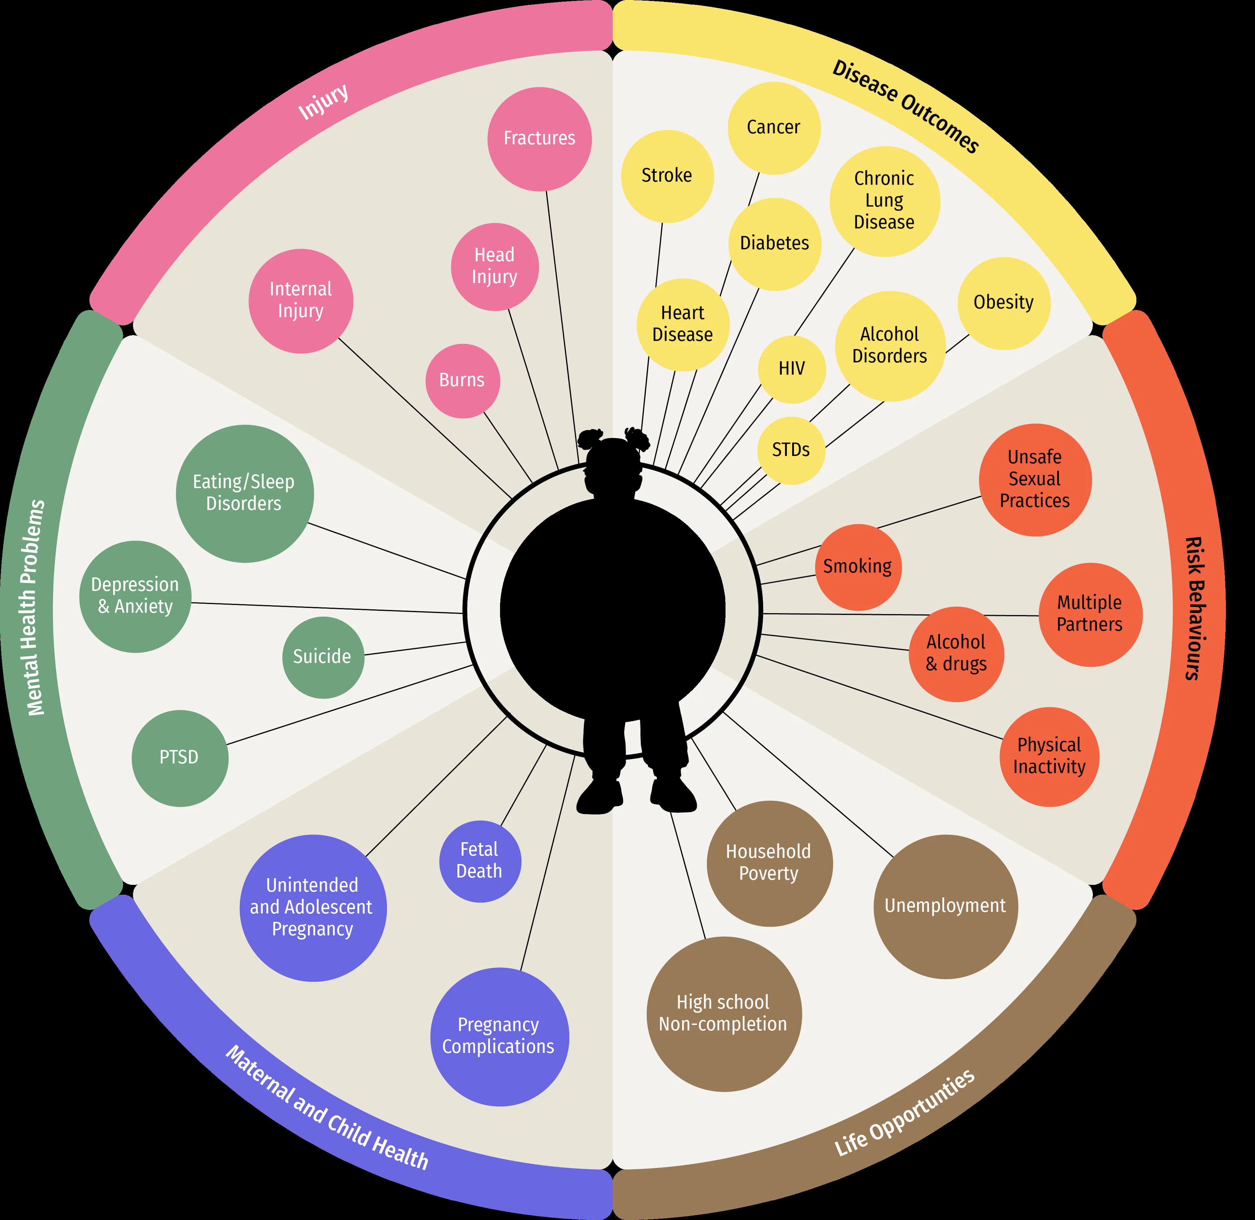
The centre of expertise on child sexual abuse includes the following as some of the impacts on young people:
- Challenges with mental health and well-being, including anxiety disorders, depression, eating disorders, sleep disruption and insomnia, leading to Post Traumatic Stress Disorder (PTSD) or personality disorders.
- Impacts on physical health, including gastrointestinal and / or gynaecological problems, pain or weight gain / loss.
- Impacts on sexual functioning and relationships in adolescence and adulthood.

Research carried out by University College London, shows that 94% of women who are raped experience Post Traumatic Stress Disorder (PTSD). In addition, 33% of women who are raped contemplate suicide and a further 13% attempt suicide.

Impact on Health and Health Services:

Sexual violence and abuse have profound and long-term impacts on physical and mental health and are a significant driver of avoidable demand across the NHS, including primary care, emergency services and mental health provision. People affected are more likely to experience trauma-related mental ill health, chronic conditions, substance misuse, and repeat presentations to health services, often without the underlying cause being identified or addressed. This creates pressure across the system and exacerbates existing health inequalities.

This strategy therefore prioritises early, trauma-informed intervention and integrated pathways between health services, specialist sexual violence provision and community partners. By improving identification, access and coordination of care, the partnership will support better health outcomes, reduce crisis escalation, and contribute to long-term system sustainability. This approach aligns with the NHS 10-Year Plan priorities on prevention, integration and equity, and positions the sexual violence and abuse response as a core component of effective population health management.

    - Impact: cost of consequences
Evidencing the costs of sexual violence The national lifetime economic cost of sexual violence and abuse against adults for England and Wales in the year ending September 2024 was estimated to be a total of over £400 billion, broken down against adult costs estimated at £292 billion, and for children £148 billion, calculated across:
- Health and social care services (physical and mental health and social care)
- Justice system (police, criminal justice, civil justice, and incarceration)
- Cost to specialist services
- QALY (Quality-Adjusted Life Years) loss
- Productivity loss
£13.8 billion is the estimated lifetime burden of sexual violence for children and adults who were victims in the previous 12 months (2024/25) in Southend, Essex, and Thurrock.
However, it is important to note that the calculator results are an estimate. A breakdown of services costs across Southend, Essex and Thurrock along with caveats is detailed at Appendix 7.4

2. Background: Facts and Figures - the scale of the problem

The priorities and action plan will continue to be developed based on the findings of the Sexual Violence and Abuse Data and Performance Working Group into prevalence across Southend, Essex and Thurrock. Gathering robust data and producing a comprehensive needs assessment of all SVA is a priority for the SVASPB. A data pack used for context to this strategy is available to professionals on request.
  - National Context:
2.1.1 Policing: The Strategic policing requirement for 2025 recognises Violence against Women and Girls (VAWG) as a national threat requiring a strategic policing response.
From policing insight: In England and Wales, public protection refers to the core policing function to prevent and reduce harm through safeguarding, investigation, tackling perpetrators and working in partnership. It incorporates 14 threat areas with particular focus on VAWG. The threat areas are adults at risk; child abuse; child exploitation; domestic abuse (DA); female genital mutilation (FGM); forced marriage; honour-based abuse; missing people; modern slavery; MOSOVO (management of sexual offenders and violent offenders); rape and sexual violence; sex work; stalking and harassment; and vulnerability to radicalisation.

    - The Crime Survey for England and Wales (CSEW) provides the best measure of victimisation and for year the ending March 2025 estimates:​
    - 900,000 victims of sexual assault
    - 15.9% of people aged 16 years and over (7.7 million) had experienced sexual assault (including attempts) since the age of 16 years.

    - Rape Crisis in their 2024 report summarised the scale of the problem as:
- 1 in 4 women have been raped or sexually assaulted since the age of 16, 1 in 18 men, and 1 in 6 children sexually abused. ​
- Fewer than 3 in 100 rapes result in a charge in the same year ​
- 5 in 6 women who are raped don’t report – and the same is true for 4 in 5 men. ​

Baroness Casey, in the National Audit on Group-based Child Sexual Exploitation and Abuse published in 2025, identified that, whilst there is currently limited data:
- Around 500,000 children a year are likely to experience child sexual abuse (of any kind). However, for the vast majority, their abuse is not identified, and it is not reported to the police either at the time or later.
- Police recorded crime data shows just over 100,000 offences of child sexual abuse and exploitation were recorded in 2024, with around 60% of these being contact offences (and the remainder online offences).
- Of these contact offences, an estimated 17,100 are ‘flagged’ by police as child sexual exploitation in police recorded crime data.
- The only figure on group-based child sexual exploitation comes from a new police dataset (called the Complex and Organised Child Abuse Dataset - COCAD) which, while suffering a number of limitations, has identified around 700 recorded offences of group-based child sexual exploitation in 2023.
Given how under-reported child sexual exploitation is, the flaws in the data collection and the confusing and inconsistently applied definitions, it is highly unlikely that this accurately reflects the true scale of child sexual exploitation, or group-based exploitation. It is a failure of public policy over many years that there remains such limited, reliable data in this area.

Following the Independent Inquiry into Child Sexual Abuse (IICSA), published in November 2022, participants of the ‘I will be heard" movement made suggestions for change including the need for increased awareness of child sexual abuse, a focus on strategies to prevent it, and a need for better identification and response, including more training for professionals

    - In November 2024 the Child Safeguarding Practice Review Panel published The Child Safeguarding Practice Review Panel - I wanted them all to notice. The key findings of this review illustrate the scale of the challenge facing practitioners, and indeed wider society, in identifying, responding to and preventing child sexual abuse in the family environment. They highlight a systemic failure across all agencies to recognise and respond when children are at risk of, or are already, being sexually abused by someone in their family environment.

    - The 2021 OFSTED review of sexual abuse in schools and colleges concluded: “this rapid thematic review has revealed how prevalent sexual harassment and online sexual abuse are for children and young people. For example, nearly 90% of girls, and nearly 50% of boys, said being sent explicit pictures or videos of things they did not want to see happens and 92% of girls, and 74% of boys, said sexist name-calling happens a lot or sometimes to them or their peers. The frequency of these harmful sexual behaviours means that some children and young people consider them normal. It recommends that schools, colleges and multi-agency partners act as though sexual harassment and online sexual abuse are happening, even when there are no specific reports.”

    - NHS England which commissions Sexual Assault Referral Centres (SARCs) reports that referrals to SARCs have increased by nearly 18% from 22,407 in 2022 to 26,374 in 2024.

    - Education: The Youth Endowment Fund Report March 2025 reports that a 2024 survey of 10,000 teenagers revealed that nearly half (49%) of 13–17-year-olds in a romantic relationship that year experienced violent or controlling behaviour — equivalent to 464,345 children in England and Wales, or 1 in 8 teenagers.

  - 2.2 Local Context:
Gathering robust data and producing a comprehensive needs assessment of all SVA is a priority for the SVASPB. The data summarised below and detailed within the data pack is that which is currently available and used to inform this strategy

    - Essex Police data and Operation Soteria

Operation Soteria is a new national funded operating model to deliver transformational change to how policing and the wider criminal justice system respond to rape. Underpinning Operation Soteria are 3 key principles:
    - Suspect Focussed
    - Victim Centred
    - Context Led
As part of adopting this model all forces were required to develop a problem profile of rape and other sexual offences (RASSO). Essex Police’s problem profile from 1/1/2020 to 31/12/2024 has been used to inform this strategy and summarises:
- 8,979 rapes (16+) and 8,930 sexual assaults (16+) over 5 years.​
- 85% of victims identified as female however the proportion of male victims has increased by 4% over 5 years.
- 91% of suspects identified as male, however the proportion of female suspects has increased by 3% over 5 years.
- Colchester and Southend had the highest RASSO offences per 1,000 population.​

For the year ending 2025, the solved rate for all sexual offences was 11.89%. This is a 2% increase on previous year. Solved rates for rape offences have since increased to 8.1%
Anecdotally there is a reported increase of peer-on-peer sexual harmful behaviour within schools. Further analysis is required of this to drive preventative work.
    - Commissioned services:
Synergy Essex
The Police, Fire and Crime Commissioner for Essex, working in partnership with the three upper-tier local authorities, commissions specialist sexual violence and child sexual abuse services to victims, survivors and their families. Synergy Essex is a partnership of rape and sexual abuse specialist services across Greater Essex delivering a range of specialist interventions in community-based centres including but not limited to Independent Sexual Violence Accredited Advisors (ISVAAs), and counselling services. Synergy Essex also provides coordinated, trauma-informed support for children and young people across Essex who have experienced sexual violence or abuse. The service includes specialist advocacy through Children’s Independent Sexual Violence Advocates (CHISVAs), play therapy, counselling, wellbeing groups, and preventative education delivered in schools and community settings. Support is available regardless of when the abuse has happened, or by whom - working in partnership with other voluntary and statutory services to ensure accessible, person-centred interventions that promote safety, recovery, and long-term wellbeing.

Overview of the year 1st April 2024 to 31st March 2025:
- 6,269 cases supported; 4,110 new referrals; 40,197 sessions delivered.​
- 88% female victims; 51% report a disability (83% mental ill-health).​
- Referrals: Self-referrals (30.6%) highest followed by criminal justice services (26.3%) and health services (19.2%), of which 87% were from mental health services. The highest areas for referrals by district were Colchester, Southend-on-Sea, and Basildon. 17.4% of police reported sexual offences were referred to Synergy.
- Survivor and Offence Profile: 63.5% of offences occurred in non-public spaces (18% not disclosed). The most supported age group was 25–34, followed by 35–44, of which 88.3% were female, and 10.5% male. 51.37% reported a disability. 83% of these had mental health issues.
- Perpetrator Relationship: Intimate / ex-partner (25.3%), relative (24%), friend / social network (15.5%), acquaintance (10.9%), stranger (7.6%), in a position of trust (2.8%), groups (0.9%), and not disclosed (13%).
- Reporting: 2,828 offences disclosed had never been reported prior to contact with Synergy Essex. 160 victims (5.6%) subsequently followed up with a police report.
- Young People: The referrals to Synergy Essex for young people aged 0-17 are shown below. After a peak in 2022/23, the last two years have been consistent. 20% of referrals were aged 0 - 12 and 80% aged 13 – 17 years. The highest presenting district was Colchester, followed by Southend and Thurrock. In the year 2024/25, 21% of perpetrators (where disclosed) were direct family members, 20% wider social network (e.g. fellow pupil, family friend), 17% intimate partner and 15% external family friend.

SARC
Jointly, NHS England, the Police, Fire and Crime Commissioner for Essex and Essex Police commission the Essex Sexual Assault Referral Centre (SARC) at Oakwood Place, Brentwood. SARCs are a safe place for victims of sexual assault to be examined, interviewed, and be referred to further support services. They support victims to understand their options and make an informed choice about how they wish to proceed. SARC examinations in 2024/25 were in line with those accessing services in 23/24. In 2024/25:
- Those accessing services were: 377 adult referrals, 221 children and young people
- 164 adults and 41 young people were referred for ISVAA support and talking therapies

Victim Support
Victim Support Essex is commissioned to provide support for victims across a range of crimes. The top crime referral to Victim Support in Essex in Quarter 2 of 2025/26 was stalking and harassment with 1,606 cases created (-40 on previous quarter), and 321 supported in the quarter.

    - MAPPA - Multi-Agency Public Protection Arrangements.
MAPPA is a statutory framework in England and Wales that brings together agencies — primarily police, probation, and prison services — to manage offenders who pose the highest risk of harm to the public.
Taken from the Essex Annual Report 2024/25:
As of 31st March 2025, there were 2,099 MAPPA-eligible individuals in the community registered as Category 1 - Sexual Offence notification requirements with 241 Sexual Harm Prevention Orders (SHPOs) imposed.
Essex’s 2024–25 figures align with national trends.

    - Local Authorities:
Learning from multi agency case audits in relation to intrafamilial child sexual abuse has identified six areas of focus:
- Public awareness / campaigns and education offer
- Training and practice toolkit for practitioners specific to CSA
- Victim / survivor care and support for adult and child
- Information sharing / recording and reporting
- Quality assurance – feedback and impact
- Perpetrator prevention and intervention
From the CSA data insights hub data from April 2024 - March 2025 reports of child sexual abuse assessments / 1,000 children are higher in Southend (2.63) and Thurrock (2.77) than the national average (2.58), whilst the volume in Essex is lower (0.89). Southend and Thurrock are on a downward trajectory, whilst Essex’s assessments have increased on previous year.
For child sexual exploitation assessments, Southend (2.15) is higher than the national average (1.02), whilst the volume in Essex (0.12) and Thurrock (0.78) is lower.
Essex Police recorded 4.6 child sexual abuse offences (excluding image based) / 1,000 children which is on a downward trajectory since 2021/22 and lower than national force average of 5.44.

    - Crown Prosecution Service (CPS)
Since 2025 CPS action plan clinics have been introduced which have been beneficial in reducing backlogs and improving file quality and an improvement in reporting against national benchmarks is expected in 2025/26 data.

    - Probation – perpetrator services

As of 10th March 2026, Essex has 998 unique cases who have been convicted of a sexual offence. Where no accredited programme has been instructed by the court a targeted intervention for sexual offenders is delivered by offender managers.

  - 2.3 Lived Experience
A survivor supported by an ISVAA said: “Nobody has thought about me once and the impact it’s had on me. You’re so real I’m so glad I reached out”
Through over 55,000 hours of service delivery by Synergy Essex, they helped 97% of survivors feel heard, understood and less isolated. 96% feel happier and healthier and 96% regain control of their lives. This looks different for different people, but could mean returning to work or education, starting or resuming exercise and self-care regimes, and building self-esteem.
Impact statements provided by victims at court have common themes expressed around emotional and psychological effects including anxiety, depression, PTSD and sleep disturbances; physical harm and health consequences; impact on daily life and routines with heightened vigilance and avoidance, and disruption of relationships leading to isolation, alongside financial and practical consequences.
From Essex County Voluntary Youth Services’ Listening Report for 2024/25, 2% of young people listed violence against women and girls as a fear. 9.3% listed harassment, of which 62% said from men and boys. 10.1% said men and boys made them feel unsafe which had doubled on the previous year.

  - 2.4 Barriers / Thematics:
We want to ensure everyone has the same level of access to justice and support but recognise that:
- Additional barriers to reporting SVA and CSA and accessing support may be experienced by everyone including deprived communities, some groups within ethnic minorities communities, the LGBTQ+ community, disabled and older victims alongside women and men from all communities.
- National reviews show higher risks in relation to the under disclosure of CSA for disabled children, and identification of boys, alongside the impact of racism and stereotypes on recognising abuse.
- Disabled women experience disproportionately high rates of sexual assault and harassment. Of survivors supported by Synergy Essex, 51.37% reported a disability, of whom 83% reported mental health issues
- The Essex SARC data for presenting adults identifies vulnerability factors of 49% where drugs or alcohol were used in the assault. 40% had a history of mental ill-health, 18% domestic abuse, 12% self-harm and 8% had a learning difficulty. Children’s data identifies vulnerability factors of 22% mental ill-health, 17% self-harm, 12% learning disability and 11% drugs or alcohol used in the assault.
A data working group will create a needs assessment to identify gaps in reporting and services for victims with protected characteristics.

3. Strategic Vision and Themes

  - 3.1 Strategic Vision:
Our vision is for partners across Southend, Essex and Thurrock to work together to prevent sexual violence and abuse, understand the prevalence and trends, reduce harm, and ensure that victims, witnesses and their families feel safe, empowered and confident to report and access specialist services should they choose to. We will acknowledge and respond to situations that may increase vulnerability, ensuring that support is accessible and sensitive to individual needs. Where SVA occurs, we will mitigate its impact through coordinated, trauma-informed specialist services and by working collectively to hold perpetrators to account.
  - 3.2 Mission Statement:
To achieve its vision, the Sexual Violence and Abuse Strategic Partnership Board will work collaboratively with partners to improve and rebuild the lives of victims / survivors across Greater Essex by prioritising reducing, understanding, and responding appropriately to sexual violence and abuse. This will be achieved through five key thematic areas, underpinned by a commitment to engaging communities in open, honest, and sometimes uncomfortable conversations that challenge stigma, promote awareness, and drive meaningful change.

  - Thematic Areas:
Participation underpins all the thematic areas: We will seek and utilise the views and experience of those with ‘lived experience' throughout each theme to inform the delivery plan.
3.3.1 Awareness and Attitudes
- We will foster community responsibility through a coordinated approach empowering residents, education providers, care providers, employers and local organisations to recognise, speak up, and take action to prevent sexual violence and abuse in all forms. This includes promoting shared responsibility for safeguarding and challenging harmful attitudes.
- We will deliver clear and consistent messaging across Greater Essex on our collective response to sexual violence and abuse, in all its forms, increasing public confidence.
- We will build trust, increase identification, develop referral pathways and offer appropriate intervention (recognising that much is currently unreported and hidden) promoting a ‘No Wrong Door’ approach for support, regardless of the service or channel the individual first accesses. This means all partners will adopt shared standards, have clear referral pathways, and practice trauma-informed support so that victims, survivors and their families experience seamless support from disclosure through recovery.

    - Support, Service Provision and Recovery

- We will ensure that services for victims, survivors and their families affected by
sexual violence and abuse are accessible when and where they are needed, regardless of demographic background.
- We will equip professionals and practitioners with the skills and knowledge to deliver high-quality, victim-centred support.
- We will work to ensure that all services for victims and survivors are trauma-informed, recognising the impact of trauma on individuals and tailoring our responses accordingly.

    - Prevention and Early Intervention

- We will increase the awareness of professionals when responding to sexual violence and abuse and encourage appropriate responses
- We will support schools and community-based organisations, and those working with young people not in education, to deliver age-appropriate Relationships and Sex Education (RSE) that includes healthy relationships, consent, challenging harmful gender norms, and equipping young people with the knowledge, skills, and confidence to reject and avoid sexually harmful behaviours both online and offline.
- We will work with further and higher educational establishments to support them in keeping students safe from sexual abuse and harassment. This includes supporting providers to educate and engage young men in recognising harmful attitudes and behaviours, fostering a culture of respect and accountability, and ensuring all students are kept safe from sexual harm.
- We will identify individuals and groups at increased risk, including those with care and support needs, to recognise signs of adult exploitative relationships, repeat victimisation, digital harms, and sexual harm in institutional settings such as care homes, supported living, and hospital/mental health wards to ensure appropriate safeguarding and early intervention.
- We will prevent harm by supporting the early identification of harmful sexual behaviour, identifying individuals and groups at increased risk, and using civil, safeguarding, and multi-agency disruption approaches at the earliest opportunity, including where criminal thresholds are not met.
    - Justice and Accountability

- We will deliver an effective criminal justice response where victims and survivors feel confident and able to support criminal proceedings and perpetrators are brought to justice.
- We will ensure Independent Sexual Violence Accredited Advisers (ISVAAs) are embedded within our justice response, in line with statutory guidance under the Victims and Prisoners Act 2024. This includes working with third-sector providers to deliver specialist, victim-focused support across the criminal justice process, so that victims and survivors receive holistic care from crisis through recovery
- We will improve the early identification of individuals who may pose a risk of perpetrating sexual violence and abuse, to enable timely intervention and prevent harm.
- We will provide appropriate services and intervention programmes for perpetrators, that are accessible regardless of demographic background, including access to social care and health services with appropriate safeguards in place
- We will protect the public, including previous victims, by ensuring sexual offenders are consistently identified, assessed, and effectively managed in the community through coordinated, multi-agency risk management involving police, probation, and prison services, and other statutory partners to reduce reoffending of sexual violence and abuse.

    - System Working

- We will, through effective collaboration and leadership, implement multi agency systems and processes that underpin partner responses to sexual violence and abuse. This includes sustaining a skilled, resilient workforce across policing and partner agencies which is critical to delivering trauma-informed, high-quality responses
- We will coordinate and oversee the collection, analysis, and interpretation of data relating to sexual violence and abuse (SVA) for both adults and children within Greater Essex to influence and inform commissioning of services alongside preventative activities.
- We will recognise where there are data inadequacies and variances between protected characteristics under the Equality Act and implement multi-agency systems and processes that support a coordinated response to sexual violence and abuse.
- We will work together to encourage shared commissioning of high quality, sustainable specialist services for victims and survivors and support research and evaluation to identify and roll out effective interventions and best practice

4. Community Equality Impact Assessment

The Community Equality Impact Assessment which is detailed at Appendix 7.1 summarised the findings as below:

This strategy aims to support all victims and survivors of sexual violence and abuse regardless of protected characteristics and therefore reduce the prevalence, alongside building confidence in all communities so that they will be supported should they choose to report.

The data group will analyse data across all protected characteristics and stakeholders to identify prevalence and trends, and the strategy and delivery plan will be continually reviewed to reflect any emerging identified patterns.

Despite this, there remains a risk that people will continue to experience abuse and violence, and the gendered nature of sexual abuse means it is more likely that women and girls will be the victims of this abuse.

Recommendations:

- Data shows 17% of victims are aged under 18, however dedicated funded services for young people are not available countywide. This is a gap that the strategy should seek to address. Our SARC supports adults and children.
- Within commissioned services, ensure that all offer a quiet space for faith and breastfeeding.
- Seek to achieve equal funding of services across Greater Essex to ensure all victims of SVA, regardless of age and whether in a domestic or non-domestic setting received equitable access to services.
- Use the Victim Gateway portal to ensure signposting for specialist services e.g. Galop supporting gender reassignment.
- The delivery plan needs to have a focus on referral pathways for those with complex needs such as mental ill-health, alongside appropriate funding to support referrals from health services.

5. Monitoring and Evaluation

  - 5.1 Governance
Will be exercised through reporting to the SVASPB on progress against the agreed delivery plan and outcomes framework.
An annual report will be taken to Safer Essex and shared with safeguarding boards.
  - 5.2 Delivery and Outcomes Framework
The SVASPB will review progress against the delivery plan at least every six months with partners requested to update on progress to actions. See below for high level delivery plan against outcomes.
 | Theme |  | Strategic Actions |  | Strategic Outcomes
1. Awareness and Attitudes |  | - Create a consistent public education communication strategy, coordinated across all partners.  - Promote shared responsibility for recognising and responding to sexual violence.  - Improve clarity, visibility, and accessibility of referral pathways across all sectors. |  | - By March 2027, establish a SVA communication campaign promoting clear and consistent messages across Greater Essex  - See a 10% increase in website hits to the victims gateway by April 27  - Baseline staff confidence in identifying and responding to sexual violence disclosures by March 2027 and increase this confidence by March 2030  - Offer of SVA trauma informed practice training available to all professionals by June 2027
2. Support, Service Provision and Recovery |  | - Research and seek to adopt quality mark for commissioners of sexual violence and abuse services  - Strengthen the interface between specialist SVA services, services working with people experiencing exploitation (including those that sell sex) mental health support, the criminal justice system and social care to ensure no wrong door to support.  - Equip all professionals with the skills and competencies for victim-centered support.  - Embed trauma-informed practice consistently across the system |  | - Implement quality mark with all relevant commissioners accredited by Q2 2028/9  - Partners will work collaboratively to deliver a coordinated and aligned system of support and support pathways are clear, consistent and accessible, measured through:  - Reduce disparity between number of victims accessing specialist support services and reporting to Police.  - Reducing time from disclosure to services referral.  - Sustain current victim satisfaction rates.  - Reduced repeat victimisation rates for a RASSO offence.  - Reduced repeat victim of RASSO by the same suspect.
 | 3. Prevention and Early Intervention |  | - Strengthen workforce confidence to recognise early signs of risk and support families and peers.  - Establish an ‘Education Subgroup’ that works across the VAWG Steering Group, SETDAB, and SVASPB to support education providers (including further and higher education) in delivering high quality relationships and sexual education across Greater Essex.  - Expand outreach to vulnerable and hidden populations.  - Investigate how multi agencies identify and work with children exhibiting harmful sexual behaviour and potential harmers to deliver early preventative work |  | - By March 2027, to have shared with educators a range of evidence-based school and community programmes to challenge misogyny and teach young people about healthy relationships, boundaries and keeping safe.  - Increase the number of healthy relationships workshops delivered by the Joint Education Team each academic year, measured through work of the Essex Police / Essex Fire and Rescue Service Joint Education Team.  - Deliver 6 targeted community engagement events a year.  - By March 2027, improve early prevention by analysing how multi-agency partners identify and work with children at risk of causing sexual harm, and by developing a consistent, evidence-informed approach to early support rather than crisis response
4. Justice and Accountability |  | - Continue to strengthen the criminal justice response and management of offenders across all partners.  - Promote awareness and accessibility of ISVAA services from crisis through to recovery, ensuring clear pathways to support across community settings.  - Improve early identification of those at risk of perpetration by mapping and identifying gaps in harmful sexual behaviour services.  - Commission research on strengthening perpetrator-focused interventions. |  | - Workshop held with CJS partners to identify barriers and seek solutions by Dec 2026  - Victims feel confident to report as well as supported and encouraged to pursue criminal proceedings, measured through:  - Increased reporting rates of sexual offences (female).  - Increased sexual offences solved (female)  - Increase in rapes solved.  - Increase in conviction rates.  - Reduce average time from report to resolution.  Justice outcomes will be assessed not solely by court results, but also by whether victims feel believed, informed, safeguarded, and supported throughout the process.  - Establish sustainable behaviour change programmes providing opportunities of rehabilitation for perpetrators by Sept 2027.  - Increase compliance rates of SHPOs and SROs  - Increase the offer, where appropriate, of restorative justice services for sexual abuse-related offences.
5. System Working |  | - Deliver on our commitments within this strategy through our multi agency sexual violence and abuse strategic partnership.  - Standardise data collection, sharing analysis across all agencies.  - Identify and address inequalities in data relating to protected characteristics.  - Strive to plan and deliver coordinated, sustainable commissioning of sexual violence specialist services that meets the Victims’ Code within Duty to Collaborate |  | - Develop and launch a standardised data dashboard by Dec 2026, updated biannually across all agencies.  - All partners submit required data on protected characteristics with 95% completeness by March 2028.  - Deliver annual survivor voice feedback reports, with priority actions agreed and completed annually.  - Monitored through shared outcomes and provider KPIs that demonstrate sustained positive experiences and access to support from those accessing commissioned specialist services

6 Risks and Challenges

  - 6.1 National
Since February 2023, violence against women and girls (VAWG) has been legally and strategically recognised by the UK Government as a national threat, meaning:
- Police forces must treat it with the same national priority as terrorism and serious organised crime.
- Police and Crime Commissioners must address it explicitly in their plans.
- Forces must develop capabilities aligned with national expectations

  - 6.2 Local
The SVASPB will monitor and mitigate key risks and challenges which are currently summarised as:
Risk Category | Potential Impact on Sexual Violence and Abuse Strategy
Political: Devolution, local government reorganisation, NHS structural changes, police reform. | Potential disruption to strategic alignment, commissioning pathways, potential for loss of key personnel and delays in decision making through transition impacting delivery and consistency.
Economic: Funding uncertainty for services alongside rising demand. | Impact on attrition of victims and survivors, therefore affecting criminal justice outcomes with increased pressure on already stretched services, and reduced ability to sustain specialist provision and meet rising need.
Social: Myths / stigma causing barriers in particular for minority groups. Aging population of offenders with limited specialist provision. | Reduced engagement from victims / survivors, and inequitable access.  Unaddressed offender risk due to insufficient specialised interventions.
Technological: Online exploitation, deepfake abuse. | Need for enhanced digital forensics capacity, expanded prevention messaging, and adaptation of service models for online harms.
Environmental: Court backlogs increasing demand on specialist services. | Extended trauma for survivors awaiting justice and increased caseloads for specialist support services / placements.
Legislative: A changing national legislative and strategic landscape will bring risks for local sexual violence strategies, | National change may outpace local capacity, bringing increased volume and complexity of sexual violence cases. Could lead to inconsistent local implementation due to funding or resource variation. Delays in national reforms may leave gaps in guidance.
Organisational: Unequal availability of commissioned services across Southend, Essex, and Thurrock. | Inconsistent access to support, gaps in provision for young people and stalking advocacy, and varying local investment levels.

7. Appendices

Appendix 7.1 Community Equality Impact Assessment

Appendix 7.2 Definition

Appendix 7.2.1 Summary of the Sexual Offences Act 2003
The Sexual Offences Act 2003 modernised laws on sexual offences in England and Wales. It redefined offences such as rape, sexual assault, and grooming, and introduced new protections for children and vulnerable adults.
Key provisions include:
- Expanded definitions of rape and sexual assault.
- Clear definition of consent.
- Specific offences against children and vulnerable adults.
- Introduction of Sexual Harm Prevention Orders (SHPOs) and Sexual Risk Orders (SROs).
- New offences such as voyeurism, exposure, and sexual grooming.
Amendments via the Police, Crime, Sentencing and Courts Act 2022 & Crime and Policing Bill 2025
Significant amendments include:
- Strengthened notification requirements for sex offenders.
- Introduction of virtual notification systems.
- Police-initiated reviews of indefinite notification orders.
- Expanded offences including spiking and coercive sexual activity.
- Lowered rank for warrant applications in offender risk assessments.
Controlling and coercive behaviour is defined in UK law (under the Serious Crime Act 2015) as: A pattern of acts of assault, threats, humiliation, intimidation or other abuse that is used to harm, punish or frighten a person, and which has a serious effect on them. Key elements include:
- Repeated or continuous behaviour (not a single incident).
- Purpose or effect: The behaviour causes the victim to fear violence on at least two occasions or experience serious alarm or distress that substantially impacts their day-to-day activities.
- Examples: Isolation from friends / family, monitoring movements, controlling finances, restricting access to resources, threats, and degrading treatment.

7.2.2 Working Together to Safeguard Children (2023), defines sexual abuse as:
‘Involves forcing or enticing a child or young person to take part in sexual activities, not necessarily involving a high level of violence, whether or not the child is aware of what is happening. The activities may involve physical contact, including assault by penetration (for example, rape or oral sex) or non-penetrative acts, such as masturbation, kissing, rubbing, and touching outside of clothing. They may also include non-contact activities, such as involving children in looking at, or in the production of, sexual images, watching sexual activities, encouraging children to behave in sexually inappropriate ways, or grooming a child in preparation for abuse. Sexual abuse can take place online, and technology can be used to facilitate offline abuse. Sexual abuse is not solely perpetrated by adult males. Women can also commit acts of sexual abuse, as can other children.’ (Page 162)
In addition, assault by way of penetration using objects (i.e. pencils, sex toys, vegetables) would also be considered child sexual abuse.
While there is no single agreed definition of intrafamilial child sexual abuse within the family environment, this is broadly understood as child sexual abuse by a relative such as a parent, stepparent, sibling, grandparent, or those closely linked to the family, such as a parent’s partner, or someone within the home environment with caring responsibilities, such as a foster carer. Some definitions have set a wider remit, and include family friends, neighbours and babysitters within the definition of intrafamilial child sexual abuse.
"Perpetrators of child sexual abuse exploit secrecy and exert power and control to silence their victims. Unlike neglect or physical abuse, child sexual abuse is an invisible harm, making it harder to detect. Child Sexual Abuse is perpetrated by individuals from diverse backgrounds, regardless of socio-economic status, education, or cultural identity. Crucially, sexual abuse can occur even when victims show no apparent risk factors or vulnerabilities and often relies on professionals ‘uncovering’ the sexual abuse, through information sharing and mapping, as well as observations of children’s behaviour and creating conditions where children feel safe enough to tell us. This is further highlighted by the November 2024 Child Safeguarding Practice Panel report, “I wanted them all to notice”
In England the age of consent for sexual activity is 16 years of age, however those over 16 years of age can still be subjected to intrafamilial child sexual abuse. The Sexual Offences Act 2003 identifies sexual activity between family members or close relatives as illegal and punishable by prison, regardless of whether children are over or under 16 years of age. The law is clear that anyone under 13 years old can NEVER legally give consent. Therefore, sexual activity with a child 13 years or under is considered statutory rape, and any sexual activity with a child under the age of 13 years of age should result in Child Protection Consultation being initiated. Throughout this practice guidance the term ‘child’ will refer to anyone under 18 years of age.

Appendix 7.3 Legal Framework and Related Strategies

Appendix 7.3.1 Statutory Duties to Tackle SVA by Responsible Authority:
1. Integrated Care Boards (ICBs):
- Under the Victims and Prisoners Act 2024, ICBs must collaborate with Police and Crime Commissioners (PCCs) and local authorities to commission support services for victims of sexual violence.
- They must prepare and publish local strategies informed by needs assessments and consultations.
- ICBs are accountable under the Serious Violence Duty to prevent and reduce sexual violence.
- They must commission trauma-informed specialist services and work with ISVAAs.
2. Police and Crime Commissioners (PCCs):
- Must collaborate with ICBs and local authorities to commission victim support services.
- Are required to publish joint strategies under the Victims and Prisoners Act 2024.
- Hold police forces accountable for providing an effective response to sexual violence.
- Lead local coordination of community safety and criminal justice partners.
3. Police:
- Have a statutory duty under the Serious Violence Duty to collaborate and share data to prevent sexual violence.
- Must respond to disclosures, investigate offences, and refer victims to support services.
- Are required to work with ISVAAs and participate in Multi-Agency Risk Assessment Conferences (MARACs).
- New duties under the Crime and Policing Bill 2025 include mandatory reporting of child sexual abuse.
4. Fire and Rescue Services:
- As specified authorities under the Serious Violence Duty, fire and rescue services must collaborate in local strategies to reduce sexual violence.
- They must share data and intelligence to support prevention efforts.
- They must engage in safeguarding training and awareness, especially during home visits and community outreach.
- They must support multi-agency responses to vulnerable individuals at risk of abuse
5. National Probation Service:
- Is required to manage offenders convicted of sexual violence and ensure compliance with safeguarding measures.
- Must contribute to Serious Violence Duty strategies and share data with local partners.
- Must collaborate with police, ICBs, and local authorities to support rehabilitation and prevent reoffending.
- Must participate in Multi-Agency Public Protection Arrangements (MAPPA) for high-risk individuals.
6. Local Authorities:
- Must collaborate under the Serious Violence Duty Act to reduce sexual violence.
7. Education Sector:
- Schools must follow statutory guidance under the Education Acts 2002 and 1996 to teach Relationships and Sex Education (RSE).
- Are required to address sexual harassment and violence through curriculum and safeguarding policies.
- Must implement whole-school approaches to prevent abuse and respond to disclosures.
- Must comply with Keeping Children Safe in Education guidance.

Appendix 7.3.2 Key Legislation:
- Crime and Policing Bill 2025 – includes a range of measures to tackle serious violence, child sexual abuse and violence against women and girls
- Victims and Prisoners Act 2024 - establishes a statutory duty for relevant authorities to collaborate by working together when commissioning victim support services for victims of domestic abuse, sexual abuse and serious violence
- Serious Violence Duty 2022 – requires responsible authorities to treat sexual offences — including serious sexual violence — as part of their strategic multi-agency efforts to prevent and reduce serious violence in their communities
- Sexual Offences Act 2003 - see detailed definition in 7.3
- Sexual Offences Act 1956 – consolidated laws relating to sexual crimes, including abduction, procuration and prostitution of women

Appendix 7.3.3 Related Strategies:
- Police and Crime Plan 2024–2028 – Supports the Southend, Essex and Thurrock SVA Strategy by prioritising protection of vulnerable people, prevention of harm, and victim-centred approaches.
- The Essex PFCC’s Commissioning Strategy 2025-26 sets out the principles, strategic approach, and framework within which the PFCC will commission services to support the delivery of the priorities set out in the Police and Crime Plan 2024 - 2028
- Essex Domestic Abuse Commissioning Strategy 2025–30 - Aligns with the SVA Strategy through shared goals of trauma-informed support, multi-agency collaboration, and safeguarding victims.
- Essex Police Force Plan 2024–26 - Reinforces the Southend, Essex and Thurrock SVA Strategy by making rape and serious sexual offences (RASSO) a policing priority and improving criminal justice outcomes.
- SETDAB Domestic Abuse Strategy 2025 – Complements the SVA Strategy by addressing sexual violence within domestic abuse contexts and promoting coordinated safeguarding responses.
- Essex Violence and Vulnerability Strategy – Supports the SVA Strategy through early intervention and prevention work targeting exploitation and serious violence affecting young people.
- National VAWG Strategy 2025 - Provides the national framework that the Southend, Essex and Thurrock SVA Strategy aligns with, focusing on prevention, pursuit of perpetrators, and victim support.
- CPS VAWG Strategy 2025–30 - Strengthens the Southend, Essex and Thurrock SVA Strategy by improving prosecution standards and victim confidence in the criminal justice system for sexual violence cases.
- Southend Street Prostitution Strategy 2022 a strategy to support a risk reduction approach for women selling sex in street areas and build pathways to enable them to exit street prostitution in a safe managed way.

Appendix 7.4 Evidencing the cost of sexual violence:
There are important caveats to note when using the calculator and interpreting the results. Taken from www.vision.city.ac.uk/sexual-violence-cost-estimate/:
- The results are likely to be conservative estimates of the lifetime cost burden of sexual violence.
- The cost of housing was not factored into the calculations because it is not captured in the Rape Crisis dataset.
- The variation in prevalence of sexual violence and abuse between local areas was not factored in due to relative low prevalence in the population. The prevalence of SVA is not the same across England and Wales localities. As a result, the calculation could overestimate the burden of SVA in wealthy areas with older populations and underestimate it in poorer areas with younger populations. While the calculator may overestimate the burden of sexual violence and abuse, given its conservative nature and that some costs attributable to sexual violence were not considered, this is unlikely, albeit possible.
Essex breaks down to:
Population | Essex | Southend | Thurrock | Greater Essex
Total lifetime costs per adult victim: | £267,371 | £267,371 | £267,371
Total lifetime costs per child victim: | £507,149 | £507,14 9 | £507,149
Total lifetime costs of sexual violence (Adults): | £7,344,956,158 | £868,956,628 | £809,600,206 | £9,023,512,991
Total lifetime costs of sexual violence (Children): | £3,790,434,242 | £455,420,116 | £534,535,415 | £4,780,389,773
Final Grand Total: | £11,135,390,400 | £1,324,376,744 | £1,344,135,620 | £13,803,902,764
Lifetime costs by service area for adults and children are as follows:
Service Area | Essex | Southend | Thurrock | Greater Essex
Education | £4,858 | £584 | £685 | £6,127
Physical Health | £34,133,577 | £4,051,683.44 | £3,987,216 | £42,172,477
Mental Health | £750,743,750.50 | £89,218,991 | £89,451,880 | £929,414,622
Social Care | £142,674,176 | £17,142,281 | £20,120,228 | £179,936,684
Police | £289,601,347 | £34,385,006 | £33,980,826 | £357,967,179
Criminal Justice | £435,309,865 | £51,671,636 | £50,849,474 | £537,830,975
Civil Justice | £217,582,946 | £25,827,273 | £25,416,328 | £268,826,547
Incarceration | £740,479,966 | £88,050,072 | £89,078,313 | £917,608,350
Specialist Services | £1,263,169,129 | £149,935,795 | £147,496,501 | £1,560,601,425
Quality adjusted life years Loss | £6,905,855,018 | £821,821,342 | £841,618,762 | £8,569,295,122
Productivity Loss | £355,837,068 | £42,272,234 | £42,135,548 | £440,244,850

Appendix 7.5 Glossary:

Acronym | Description
ASE | Adult Sexual Exploitation
CHISVA | Children’s Independent Sexual Violence Advocate
CJS | Criminal Justice Service
CPS | Crown Prosecution Service
CQC | Care Quality Commission
CSA | Child Sexual Abuse
CSE | Child Sexual Exploitation
IAPT | Improving Access to Psychological Therapies (Talking Therapies)
IICSA | Independent Inquiry into Child Sexual Abuse
ISAC | Independent Stalking Advocacy Caseworker
ISVAA | Independent Sexual Violence Accredited Advisors
JTAI | Joint Thematic Audit Inspection
MAPPA | Multi Agency Public Protection Arrangements
MOSOVO | Management of Sex Offenders and Violent Offenders
PTSD | Post Traumatic Stress Disorder
RASSO | Rape and Serious Sexual Offences
SARC | Sexual Assault Referral Centre
SET | Southend, Essex and Thurrock
SETDAB | Southend, Essex and Thurrock Domestic Abuse Board
SHPOs | Sexual Harm Prevention Orders
SROs | Sexual Risk Orders
STI | Sexually Transmitted Infection
SVASPB | Sexual Violence and Abuse Strategic Partnership Board
VAWG | Violence Against Women and Girls

8. Services and Support available for Victims and Survivors

Synergy Essex: For anyone who has been a victim of sexual violence or abuse, Synergy Essex is a partnership of rape and sexual abuse centres in Greater Essex who deliver specialist community-based services for victims and survivors of all forms of sexual violence and abuse, sexual domestic violence, sexual harassment and child sexual abuse.
Phone 0300 003 7777
24/7 Rape & Sexual Abuse Support Line, run by Rape Crisis, is open 24 hours a day, every day of the year
Phone 0808 500 2222
Victim Support – a specialist service helping anyone affected by any types of crime, not only those who experience it directly, but also their friends, family and any other people involved. Phone: 0808 168 9111, 24 hours a day, seven days a week.
Compass – a partnership of domestic abuse services providing a central point of access for callers to speak with a trained member of the team who will complete an assessment to ensure contact is made with the most appropriate support service.
Phone: 0330 333 7444
Victim Gateway Service – a directory of services in Essex
The Centre of Expertise on Child Sexual Abuse provides several resources aimed at reducing the impact of child sexual abuse through improved prevention and better response.
NAPAC - Supporting Recovery From Childhood Abuse provides support for adult survivors
Phone: 0808 801 0331
For more national services see National VAWG Strategy – page 76

As defined in the SET-safeguarding-adult-guidelines-V10-May24.pdf
As defined in the Independent Inquiry into Child Sexual Abuse
As defined in the Independent Inquiry into Child Sexual Abuse
Infographic credited to Together For Girls
As referenced in Women's Suicide Prevention Hub - Sexual violence - Grassroots Suicide Prevention
For Essex this is the Police, Fire and Crime Commissioner (PFCC)

