**Community Remedy**

A community remedy document is a list of actions which might be appropriate to be carried out by a person who has engaged in anti-social behaviour or has committed an offence and is to be dealt with without court proceedings. The document will be prepared by the local policing body and can be revised at any time.

The community remedy document must be prepared or revised in consultation with the chief officer of police for the area, whatever community representatives the local policing body thinks it appropriate to consult and undertake whatever other public consultation it thinks appropriate. All of these viewpoints must be taken into account.

The Community Remedy applies where:

1. A person such as a police officer (P) has evidence that an individual (A) has engaged in ASB or committed an offence  
   b) A admits to P that he or she has done so  
   c) P thinks that the evidence is enough for taking proceedings against A for an Injunction or taking other court proceedings, but decides that it would be more appropriate for A to carry out action of some sort instead, and  
   d) Where the evidence is that A has committed an offence, P thinks that the matter is not so serious that a conditional caution is appropriate.

Before deciding what action to invite A to carry out, P must make reasonable efforts to obtain the views of the victim (if any) of the anti-social behaviour, and in particular the victim’s views as to whether A should carry out any of the actions listed in the community remedy document.

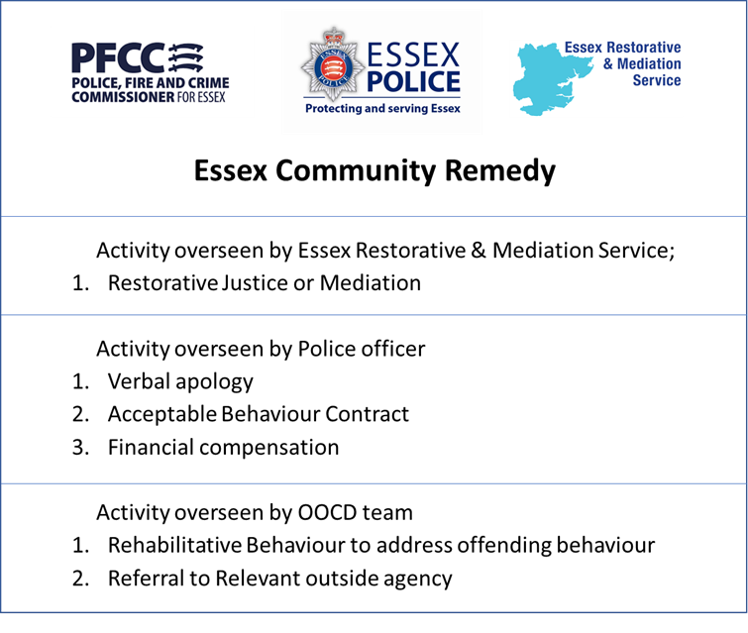

The Community Remedy document is, effectively, a menu of options that may, at the discretion of the officer dealing with an incident, be offered to a victim of ASB or “low-level” offence where a custodial or long-term community sentence is unlikely.

The menu includes activities that the offender could be asked to engage with which would result in a rehabilitative outcome for both victim and offender, rather than pursuing the matter through the courts.